***CONVERSION FROM REGULAR EXPRESSION TO NFA AND DFA***

***Ayush Jindal***

***RA1911003010308***

***AIM:*** *To write a program to convert regular expression to NFA and DFA*

# *CODE:*

*NFA=[] DFA1=[] DFA=[]*

*while 1:*

*st = input("Enter the Regular Expression and Q to exit: ") if(st=='0'):*

*break if(len(st)==1):*

*print("NFA : "+"0 "+st+" 1")*

*print("DFA : "+"0 "+st+" 1")*

*if(len(st)==2):*

*if(st[1]=='*'):*

*NFA = ("0 e 1 "+st[0]+" 2 e 3 0 e 3 2 e 1") print("NFA : "+NFA)*

*# print(NFA[0])*

*for i in range (0, len(NFA)): # print(i) if(NFA[i]==st[0]):*

*DFA1 = (NFA[i-2]+" "+NFA[i]+" "+NFA[i+2]) print("DFA : "+DFA1)*

*break*

*else:*

*print("NFA : "+"0 "+st[0]+" 1 "+st[1])*

*print("DFA : "+"0 "+st[0]+" 1 "+st[1])*

*if(len(st)==3):*

*NFA=("0 e 1 "+st[0]+" 2 e 5 0 e 3 "+st[2]+" 4 e 5") print("NFA : "+NFA)*

*for i in range(0, len(NFA)):*

*if (NFA[i]==st[0]) or (NFA[i]==st[2]):*

*DFA1 = (NFA[i-2]+" "+NFA[i]+" "+NFA[i+2])*

*DFA.append(DFA1) print('DFA : '+' '.join(DFA)) DFA=[]*

*if st=='Q': break*

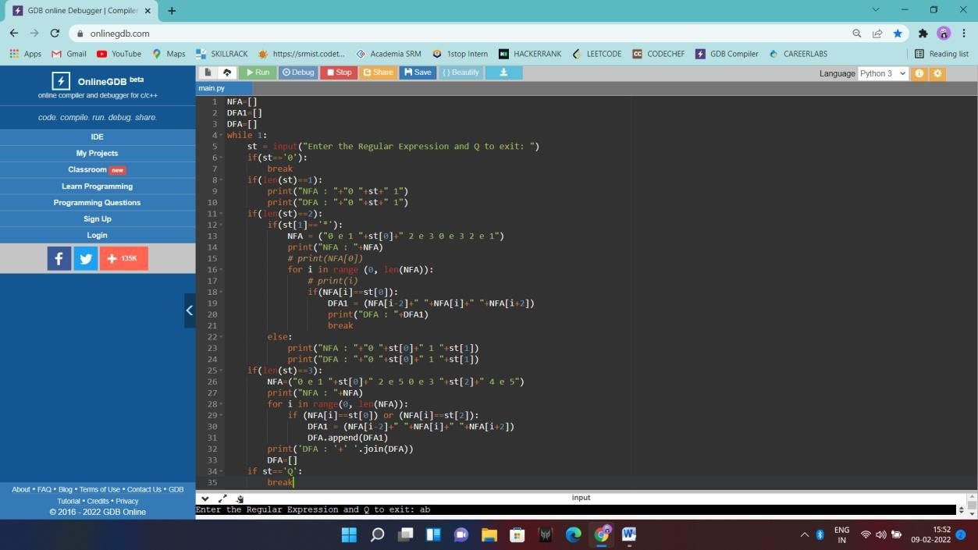

# *OUTPUT:*

# 

***RESULT:*** *Executed a program to convert regular expression to NFA and DFA.*